Created by: David Rubio G.
Blog: https://soceame.wordpress.com/
GitHub: https://github.com/DRubioG
Last modification date: 11/03/25

To activate the internal peripherals of a PolarFire SoC, you need to open the PFSoC MSS Configurator program. This is the program that configures the SoC that then has to be imported into Libero as an MSS SmartDesign.
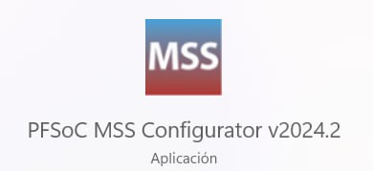

PFSoC MSS Configurator
When you open the program, you are given two options: create a new configuration or open an existing one.
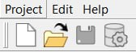
- Create a new configuration
The first thing it does is open a tab where it will ask you what type of PolarFire you are going to configure.
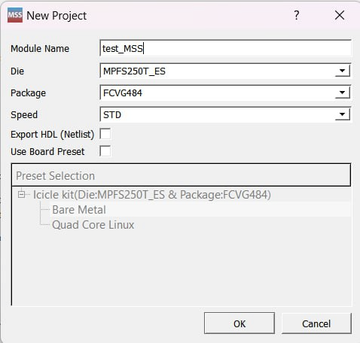
It also has an option that allows you to use a board that is already preconfigured in the program. At the moment, only the Icicle Kit is configured.
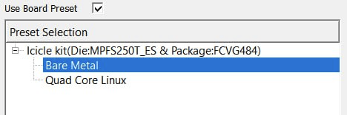
- Open an existing one
To open an existing one, it will ask you to provide the .cfg file with the configuration. From this configuration file, it will open the previously saved configuration.
Here you have a base project for the PolarFire SoC Discovery Kit: https://github.com/DRubioG/Polarfire_basic_project/tree/main/PolarFire_config
NOTE: it is recommended to work on an existing configuration because one of the characteristics that it asks for to configure the SoC is the RAM memory that the SoC has.
Once the program is opened you can see a tab like the following one, in this tab you can see all the possible configurations of the PolarFire SoC.
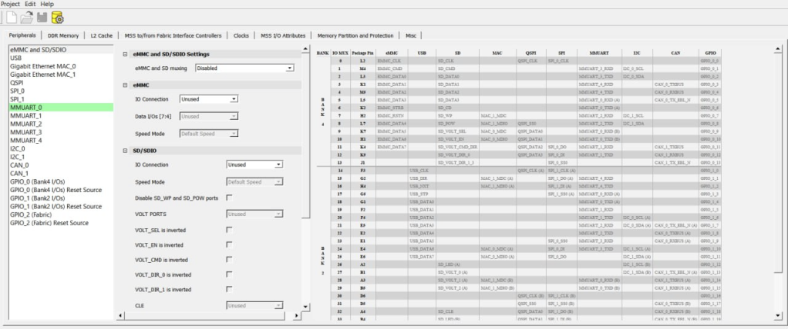
This program allows you to configure the interfaces for different peripherals (Peripherals). For example, it allows up to 5 UARTs, 2 I2Cs, 2 SPIs, GPIOs for the existing banks.
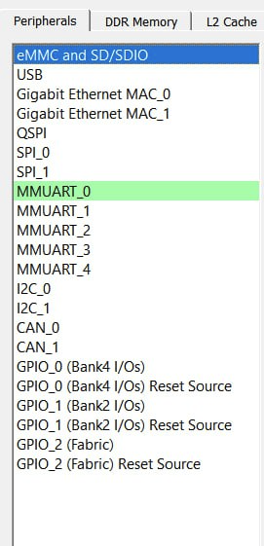
The specific pins of the SoC are the pins called «MSS I/Os Bank …«, these pins are multiplexed, so it is not possible to use all the interfaces of the SoC at the same time through these pins. To solve this, the so-called Fabric I/O pins appear, which are pins that do not belong to the SoC, but to the programmable logic of the FPGA. So, it is the user who chooses the output pins of the interface after synthesizing.
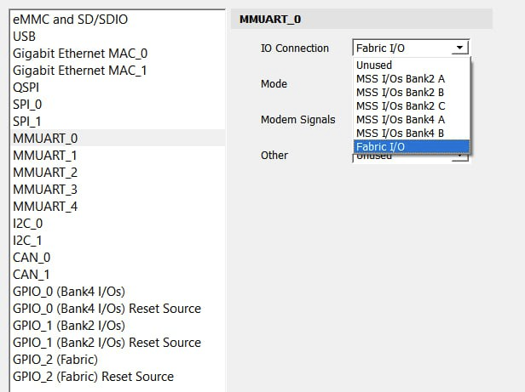
The multiplexed pin table is the following, where you can see that pins 17 and 18 are selected. These pins are in bank 2 of the SoC.
NOTE: in this pin table the specific name of the peripheral appears on the pins, so it becomes easier to know which pins to configure.
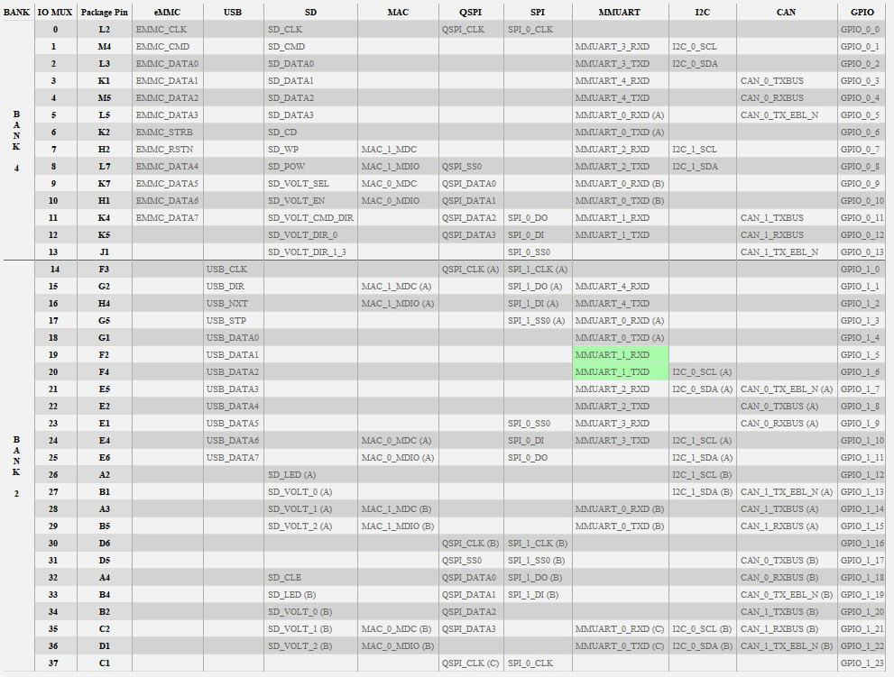
These pins correspond to the connections established in the schematic of the board for bank 2 of the SoC.
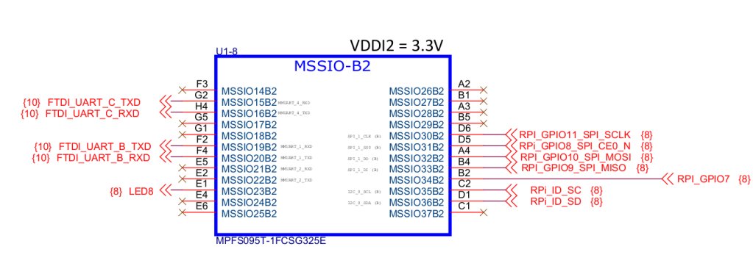
As you can see, the I2C also has the option to select the type of pin through which the connection can be established.
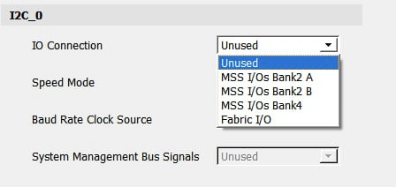
The same with the GPIOs.
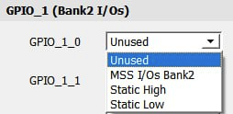
Now if you look at the GPIOs, two types of GPIOs appear, those that go through the SoC pins and those that can only go through the programmable logic (Fabric).
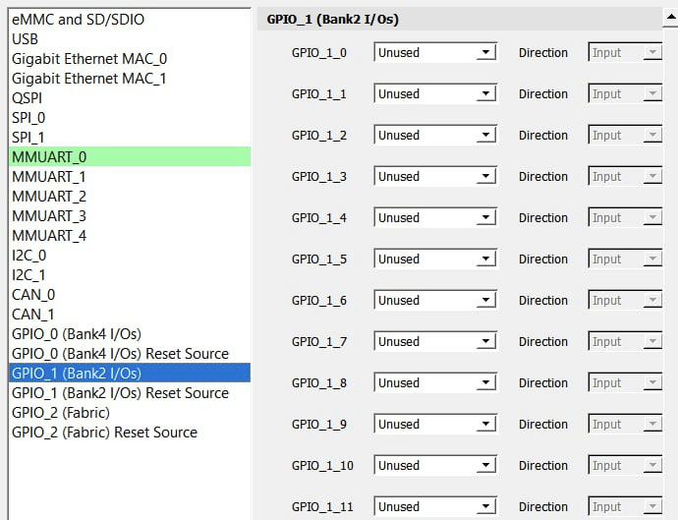
The next tab allows us to configure the RAM memory.
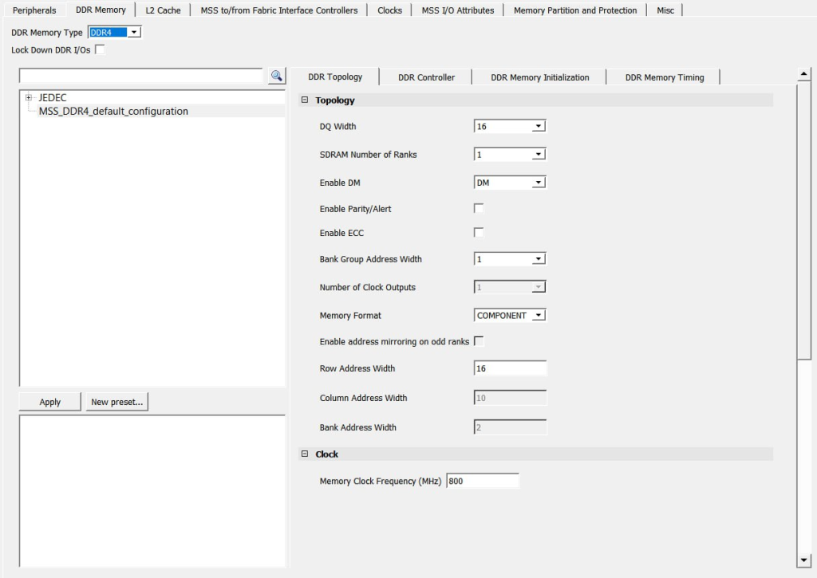
It has a lot of RAM memories inside, so unless you know specifically what memory you have in the SoC it is better to have a preconfigured profile.
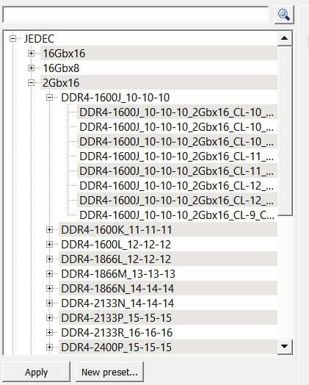
The next tab allows you to configure the L2 Cache.
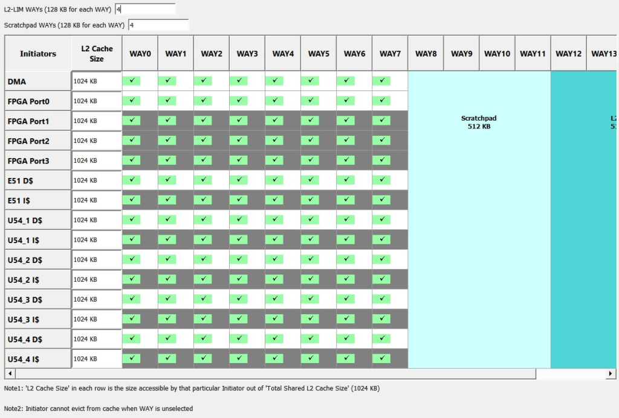
The next tab is important, because it is the one that configures the communication interface with the different IP blocks that are used in the SoC. You can see that there are up to 4 profiles, 3 for AXI and one for APB.
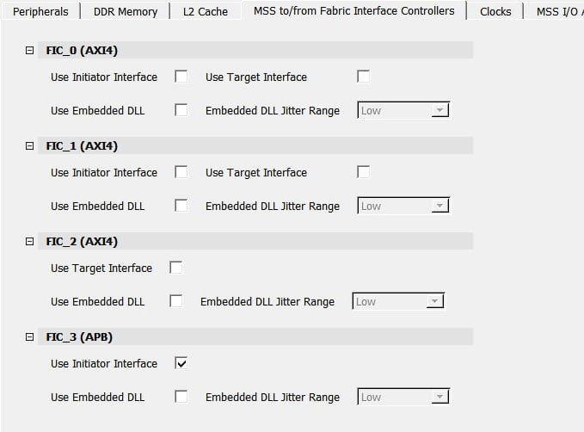
The next one is for the configuration of the output clocks of the SoC, not the input that makes the SoC work.
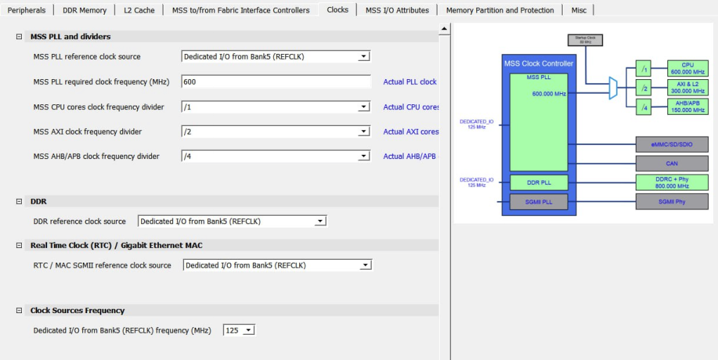
The SoC has its own clock by default, in the image you can see that it has a clock connected to the MSS_REFCLK_IN_P/N pins of 125MHz.
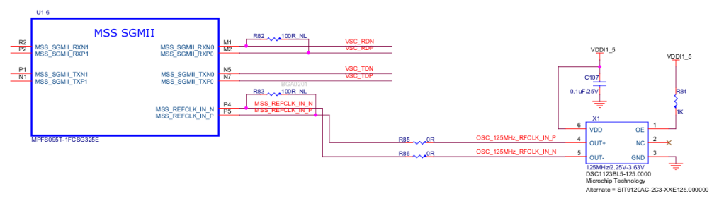
The next one is to configure the properties of the MSS pins used, such as if they are in Pull-Up, Pull-Down, etc.
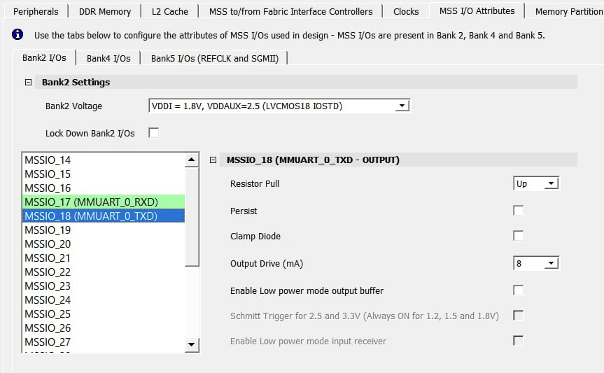
The next step is to configure the different memory zones, this is a bit complex to handle, because the SoC has at least 5 internal cores: 1 RV64IMAC and 4 RV64GC.
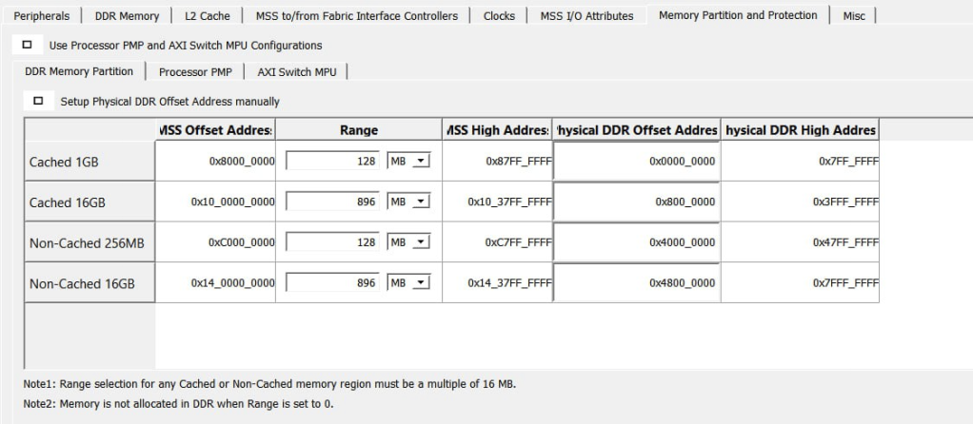
The last tab is used to configure some final options of the SoC, such as if it has an external pin for interrupts.
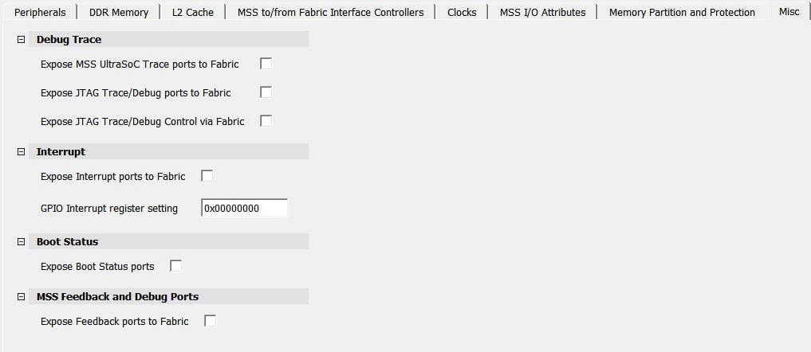
Now what you have to do is generate the component and save the configuration.
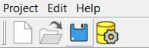
You have to create a .cxz file to use it in Libero.

Libero
The next step is in Libero. We open Libero and go to the Import MSS option.
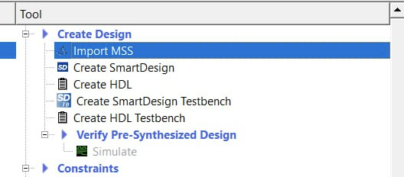
This option asks us for a .cxz file like the one generated by the PFSoC MSS Configurator.
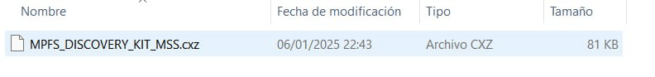
When we import it, it appears in the hierarchy.
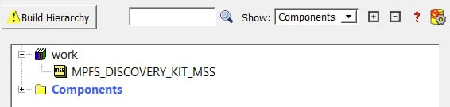
Now we just have to create a SmartDesign and add it.
When we add it, we can see that there are ports that are already selected. A differential clock appears, the APB interface selected to couple IP blocks, the RAM memory pins also appear, two GPIOs selected to be output through the MSS pins, and a UART with external pins also appears (this UART has 3 pins, the TXD_OE pin does not need to be connected).
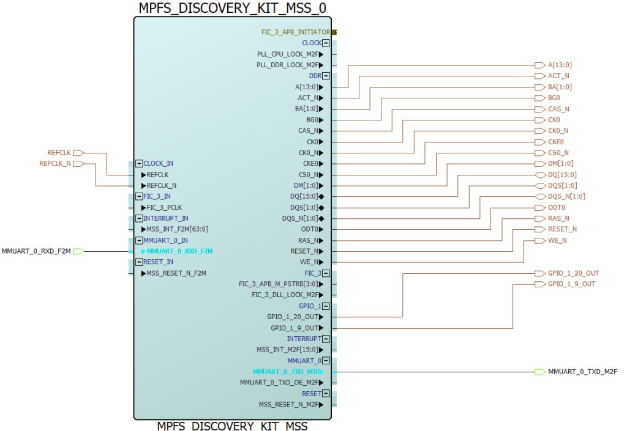
The hierarchy is as follows.
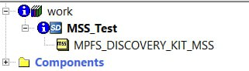
Now the only thing left to do is to generate the design with the desired IP blocks, or directly generate the bitstream, and continue with the SoftConsole.
NOTE: the UART that comes out through FABRIC, Libero asks us to assign the pins we want.
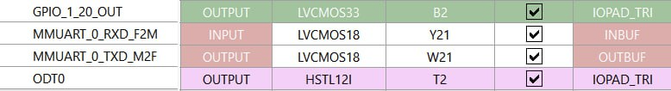

Drivers
Peripheral drivers can be obtained through SoftConsole 2022’s internal build system (this option is quite difficult to obtain) or from this GitHub repository (there may be drivers that don’t quite work): https://github.com/polarfire-soc/polarfire-soc-bare-metal-library
NOTE: Some working drivers can also be found in the examples provided by SoftConsole upon installation, for both SoftConsole 2021 and 2022.

